[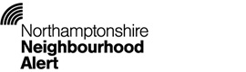](https://www.northamptonshireneighbourhoodalert.co.uk/)[](http://www.northants.police.uk/communityconnect)

[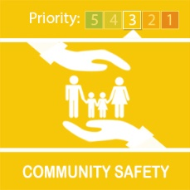](https://twitter.neighbourhoodalert.co.uk/images/msgTypes/Mt40P3.jpg)

Cold Callers

We have received a report of a security company cold calling residents in the Duston area by telephone, stating they "are working with the police".   
  
Please be advised that we have not contracted any outside agencies to conduct security or crime prevention visits or installations on our behalf.  
  
We would remind residents that they are under no obligations to book any appointments for surveys and / or contract with any company cold calling with their services. Only accept services from recommended and trusted suppliers.  
  
Please share this message with any vulnerable friends or family. Please remind them "If they are not sure, don't open the door".  
  
Further crime prevention advice can be found at <http://www.northants.police.uk/information/crime-prevention>.

You can register to receive alerts from the Northamptonshire Neighbourhood Alert:

<https://www.northamptonshireneighbourhoodalert.co.uk>